FEDERATION OF EUROPEAN WOMEN PILOTS
PROGRAM - SLOVENIJA, 5th-7th June 2026

Friday, 5th June 2026 – LJCL
Registration & Fly-in: 09:00 – evening
Event opening: 16:30
Board meeting: 17:30
We will spend the whole day at LJCL (Celje) Airport. There will be an opportunity to fly in a motor aircraft, ultralight or a glider, and details regarding prices and the schedule will be sent separately.
Food will be served at the airport (snacks, grilled food, and stew). The event will officially start at 16:30 with speeches by the President of Slovenia, Ms. Nataša Pirc Musar, who was also involved in aviation, the Mayor of Celje, and the President of our aeroclub.
The Board meeting will be held at 17:30 in the meeting room of Aeroclub Celje (1st floor).
In the evening, transfer to Thermana Laško.
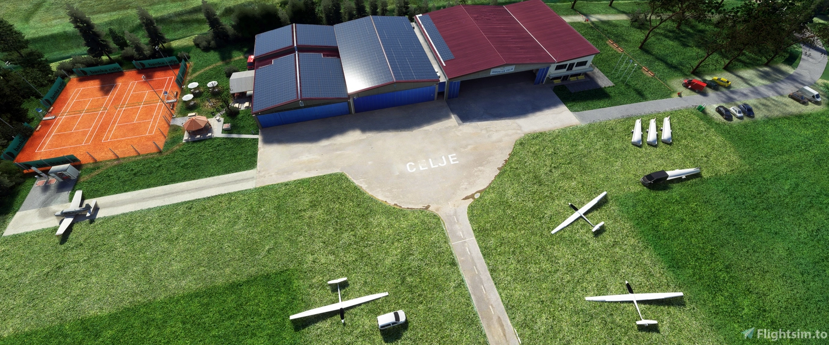

Saturday, 6th June 2026
Breakfast: At the hotel or private accommodation.
Morning: After breakfast, there is an organised bus transfer from Thermana Laško to the Old Castle, followed by a guided tour of the Old Castle and light snack. After that, we will have a bus transfer to the old town and a guided tour of the historic city centre.
Midday: We have some free time in the old city center.
Afternoon: The FEWP Annual General Meeting (AGM) will take place at PFC (Plesni forum Celje, Trubarjeva ulica 1a, 3000 Celje, Slovenia), which is a 10 minute walk from the old town. From there, a bus transfer back to Thermana Laško will be organised.
19:00 – Gala dinner at Thermana Laško.

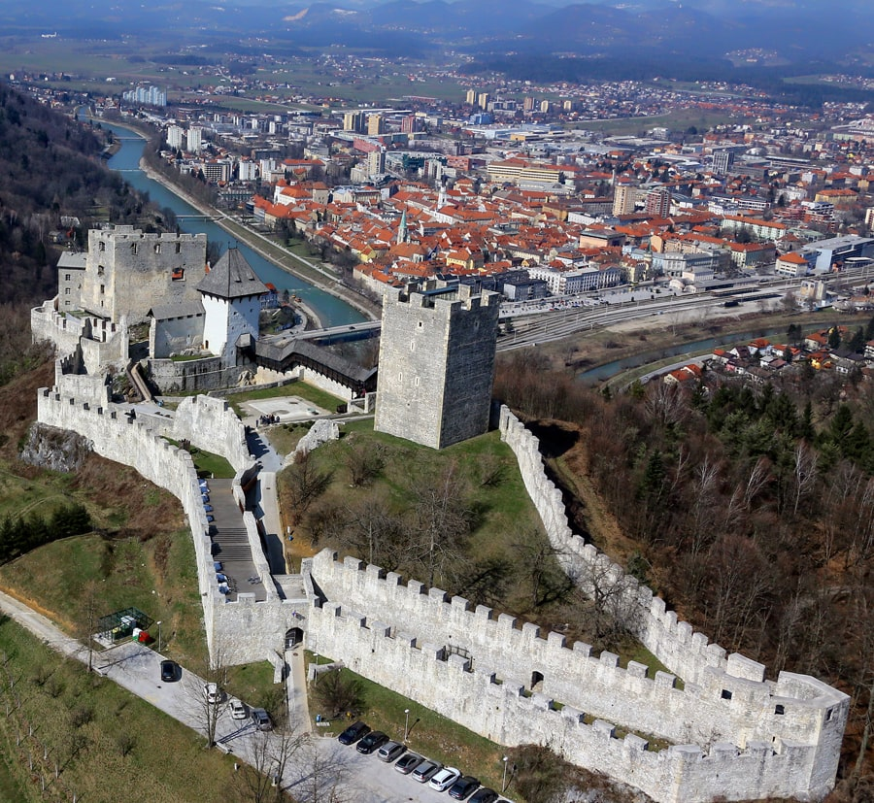

Sunday , 7th June 2026
Morning: breakfast (at your accommodation)
This will be a back-up day for flying activities in case of bad weather on Friday.
10:00: Visit to the local brewery – Pivovarna Laško – and a walk through the old town of Laško.
Brewery visit: approximately €20 per person, including a tour and beer tasting. The final price will be confirmed in March 2026.


